Increase in the Website Traffic for Anaheim Restaurant

Background
The business was already receiving an average number of 7 visitors per day on their website. They looked to do something out of the box and increase the visitors.

Goals
The business owner was familiar with digital marketing and had an average amount of 7 visitors per day on his website. Their previous work was pretty good and well managed though he needed services better than his previous agency and that too with a limited budget.

Challenges
The biggest challenge was the limited budget offered by the client to boost the traffic so that limited strategies which could be targeted only for organic growth and no paid advertising which could’ve resulted in slow or no growth at all.

Strategies
The strategies were limited and only focused one part at a time given the budget. The basic strategy included the optimization of the client’s website for different search engines, content marketing followed by keyword optimization and finally a new website for the client was built after some time when they started seeing results.
Keyword Research: Looking for different keywords used by local restaurants allowed a modification to the current website content for the client’s website.
Audit: A Technical SEO audit helped to remove the website from any possible errors to make it more crawlable by Google and other search engines.
Content Marketing: Content marketing played an important role in getting new customers for the business. This focused on custom forms for each blog to target different traffic to different target audiences-both local residents as well as tourists visiting Disneyland.
Press Release Creation and Distribution: A three month Press Release program was instituted. The goal of this program with national distribution was to improve the Websites Domain Authority scores.
New Website and Blog Content: A new website was designed for the client at the end of 2018. The client’s initial blog content wasn’t that bad but was improved and polished to cater to the reader’s that were now being targeted.

Results
The results were expected to be slow-paced but the different strategies proved to be effective in bringing the trafficking drastically up by 293%.
- Drastic Increase in Visits: The number of visitor to the client’s website jumped by 156%
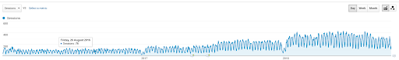
Figure1: An increase in the daily visitors to the client’s website

- Keyword Strategy Made an Impact: A drastic increase in the website traffic by 293% through Google search engine
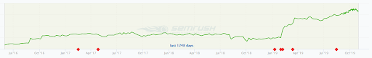
Figure2: Graph showing larger number of Google searches and better ranking after SEO implementations
- A New Beginning to the Business: Their reservation rate went up by a rate of 31% which made them very satisfied.
- Reaching New Heights of Fame: Mentioning of client’s firm by well-known websites such as Yahoo Finance and USA Today via Press Release Distribution improved domain authority by 10 points.

